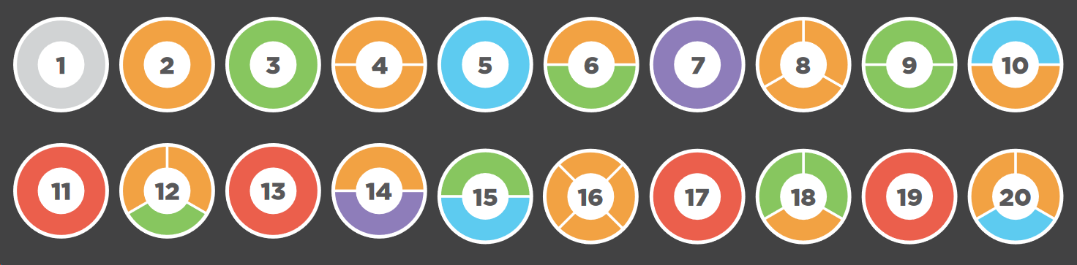

|  |  |
| --- | --- |
| What do you notice? | What do you wonder? |

