Playing with dot machines

What is the 14 machine code for 29?

What would the code 100 mean in a 1←2 machine? 1←3 machine? 1←4 machine? Do you notice any patterns?

Can you represent 25 in a 1←2 Machine? A 1←3 machine? A 1←4 machine? What patterns do you notice?

Make up your own questions, and test them on friends!

What’s going on here?

What are these machines doing?

What is the relationship between any dot in a 1←9 machine and a dot that is one box to its left?

What makes 1←10 machines different from other machines?

Does the order of the explosions matter?

Is there an easy way to find the code for the number 324 (324 dots)
in a 1←2 machine? a 1←6 machine? a 1←x machine?

What else can these machines do?

Can you convert the code 110 from a 1←3 machine to a 1←6 code? a 1←8 code?

What happens if you add two 1←10 machines together, like this:
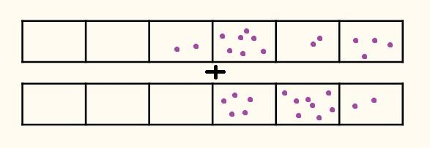
What numbers are you adding together?
How does this compare to our traditional addition algorithm for adding two numbers?

Can other operations be done with 1←10 machines?

What does a 1←x machine do?

What does a 2←3 machine do?
Could a 1←10 machine be extended to include decimal values?

