“It was a neighborhood game.
The only thing you couldn’t do was change the rules.”
Written by Joshua Ramirez, HSE Student, BMCC.

“Skellzies” is a street game I used to play with other kids in my neighborhood in the South Bronx. To play the game, we needed a bottle cap that you would get from a gallon of milk or bottle of water and some old bubble-gum, clay, or wax from a candle. We’d fill the cap with clay or wax - mash it in there, to add weight to it so the wind doesn’t blow the cap away after flicking it. My favorite cap to use was that from a gallon of Polar Springs water.
We also needed a can of spray paint. It didn’t matter what brand of spray paint it was, if it could paint, then we were good. The kids in my neighborhood preferred drawing the board on the street because the caps would glide better there. With the spray paint, we would first draw a big 6-foot square. To get a square with straight lines, we used tape to measure out the board or a big cardboard box, and traced along its’ edges. After outlining the 6-foot square, we would then draw smaller 6-inch boxes in each corner pocket inside the big square, using tape to measure as we went. We would also need to draw boxes centered on the lines between the corners. Lastly, we drew two concentric boxes at the center of the board; the bigger of those two boxes with 12-inch sides, and the smaller box having 4-inch sides. The starting line is the last thing we drew. We could have placed the starting line wherever we wanted, but we chose to have it 10 ft. away from the board.
Skellzies was a very popular game in New York City from the 1950’s through the 1980’s, but it is much less popular today. The game has probably been around as long as the crown-rimmed bottle cap, invented in 1892. I was playing this game in the late 1990’s and early 2000’s. Not too many people knew about the game then, but if you did, our friendship was automatic.
I played Skellzies a lot when I was a kid. The game used to unite all the kids in the neighborhood. That’s how fun the game was. Skellzies was also a good way to welcome a new kid to the block. A lot of talking happens over a game of Skellzies. Some kids were phenomenal with calculating angles and measuring distances and they brought with them a competitive flare to the street game. We used to travel to other neighborhoods to play Skellzies with other groups of kids and we’d play by that neighborhood’s set of rules to get a different feel for the game. What made us want to play was that we had nothing to do, or we had been playing a bunch of games that required running and we were resting our legs by playing Skellzies. But kid’s don’t play nowadays because they don’t like to get dirty. You have to be on your hands and knees in the street to play this game. Skellzies was mad fun!

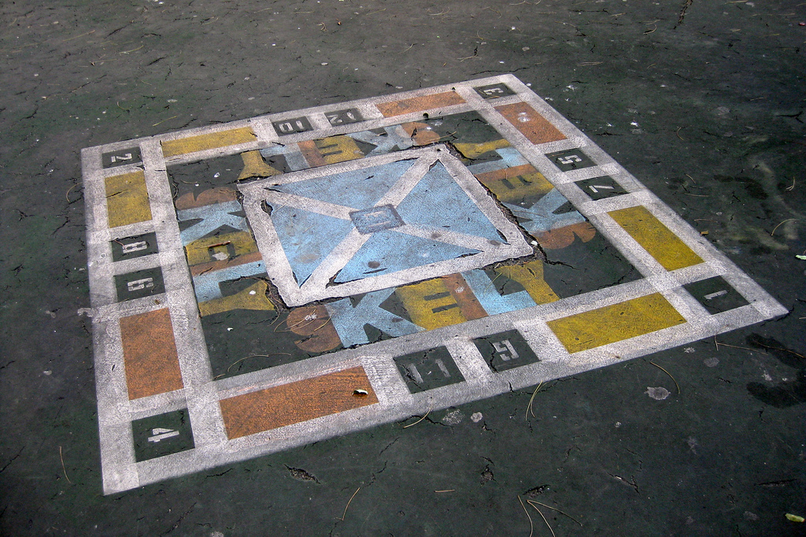
Above: One version of Skellzies, also known as “Skelly”.
Below: Bottle caps filled with melted crayons.

