Questions Inspired by Tic-Tac-Toe
By Gregory Fein

How many different possible games are there?

How many games are there where we fill the board?

What’s the fewest number of turns you can have in a game?

How many games are there that end after 5 moves?

What if we ignore the rules of the game, how many ways are there to fill the board with X’s and Os?

Ignoring the rules of the game, how many ways can you fill the board with 7 X’s and 2 O’s?

What can the board look like when the game is over? How many different configurations are there?

Who is more likely to win?

How often does X win?

How often does O win?

What would a 2 by 2 version of the game be like?

What is the best first move for X?

What is the best first move for O?

What is the worst first move for X?

Which corner is the best one to start in?

X
O
√

What could the rules of this game be?

What about these games? What do you notice? What do you wonder?

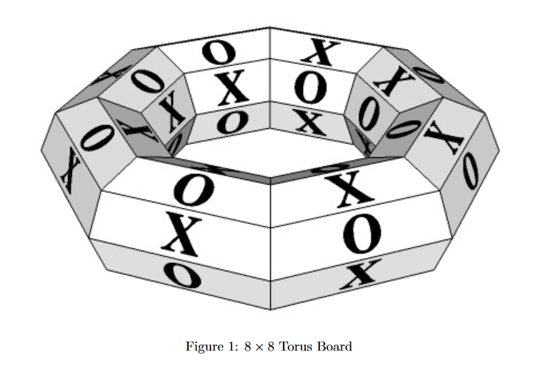
What do you notice in this picture? What do you wonder?

