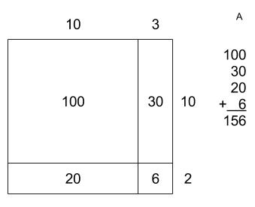 | 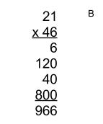 | 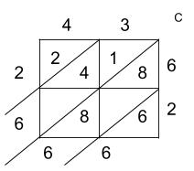
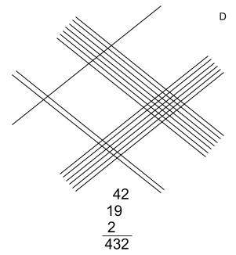 | 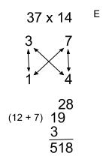 | 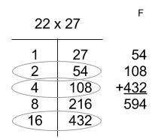
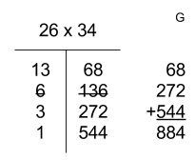 | 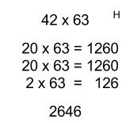

- Using this method, solve 26 x 35. Practice the method with a few other multiplication problems.
- Why does it work?
- What are its advantages? Disadvantages?
- On chart paper: Demonstrate the method with the multiplication problem 26 x 35.

- Using this method, solve 26 x 35. Practice the method with a few other multiplication problems.
- Why does it work?
- What are its advantages? Disadvantages?
- On chart paper: Demonstrate the method with the multiplication problem 26 x 35.

- Using this method, solve 26 x 35. Practice the method with a few other multiplication problems.
- Why does it work?
- What are its advantages? Disadvantages?
- On chart paper: Demonstrate the method with the multiplication problem 26 x 35.

- Using this method, solve 26 x 35. Practice the method with a few other multiplication problems.
- Why does it work?
- What are its advantages? Disadvantages?
- On chart paper: Demonstrate the method with the multiplication problem 26 x 35.

- Using this method, solve 26 x 35. Practice the method with a few other multiplication problems.
- Why does it work?
- What are its advantages? Disadvantages?
- On chart paper: Demonstrate the method with the multiplication problem 26 x 35.

- Using this method, solve 26 x 35. Practice the method with a few other multiplication problems.
- Why does it work?
- What are its advantages? Disadvantages?
- On chart paper: Demonstrate the method with the multiplication problem 26 x 35.

- Using this method, solve 26 x 35. Practice the method with a few other multiplication problems.
- Why does it work?
- What are its advantages? Disadvantages?
- On chart paper: Demonstrate the method with the multiplication problem 26 x 35.

- Using this method, solve 26 x 35. Practice the method with a few other multiplication problems.
- Why does it work?
- What are its advantages? Disadvantages?
- On chart paper: Demonstrate the method with the multiplication problem 26 x 35.

