When is Halving Not Halving
by Marian Small, Posted June 23, 2014
Exploring the relationship (or lack of relationship) between perimeter and area is interesting for students—even for simple shapes like rectangles. For example, if you cut a rectangle’s area in half, do you also cut the perimeter in half?
Using the rectangles shown below, it is easy to see that the figure on the left was cut in half to create the figure on the right. When we measure the area, the rectangle on the left is 16 units and the area of the smaller rectangle is 8 units—exactly half of the original rectangle. However, it turns out that the perimeter of the figure on the left was not cut in half when the new rectangle was created. In fact, the new perimeter is a full 3/4 of the old perimeter.

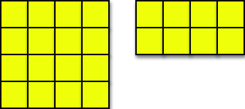

Is the new perimeter always 3/4 of the old one? Let’s try a different rectangle. This time, let’s cut it vertically instead of horizontally.

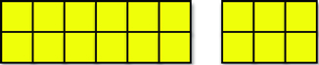

Once again, the area is halved, but the perimeter changes from 16 units to only 10 units. This time, the ratio of new perimeter: old perimeter, is not 1/2 and also not 3/4. Instead, it is 5/8.

You could provide students with square tiles with which to build rectangles, or they could explore the challenge using geoboards and geobands. Alternatively, students might digitally access squares they can put together to make rectangles using the Patch Tool at http://illuminations.nctm.org/Activity.aspx?id=3577, the Shape Tool at http://illuminations.nctm.org/Activity.aspx?id=3587, or the virtual geoboard available at the National Library of Virtual Manipulatives website.

Encourage students to then explore exactly what fractions of the old perimeter the new perimeter could be if a rectangle’s area is cut in half.

Could it be 2/3?

Could it be 1/3?

Could it be 5/6?

Could it be really close to 1?

Could it be really close to 0?

Is it ever 1/2?

Alternatively, if time is limited, ask students to determine the dimensions of rectangles with specific new perimeter: old perimeter ratios, such as 5/6 or 2/3.

Have your students try the problem and see how it goes for them.

http://www.nctm.org/Publications/Teaching-Children-Mathematics/Blog/When-is-Halving-Not-Halving/

