The Diagonal Problem – Three-Act Math Version

- Watch the video
http://www.101qs.com/3-counting-diagonals

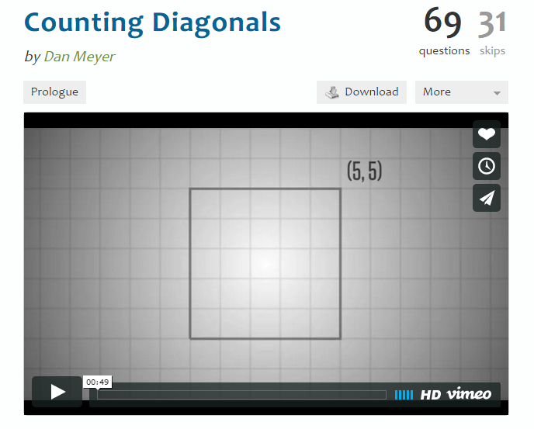

- What do you see? What do you notice?

- What are you curious about? Write a few questions you have after watching the video.

Problem by Dan Meyer

Diagonal Problem (online version)
Go to Geogebra Tool: http://tube.geogebra.org/student/m1992
When you move the point around to change the size of your rectangle, you will notice that the diagonal passes through certain squares and misses others. When the rectangle is small, it is easy to simply count the squares.
Question: How many shaded squares would there be in an n x m rectangle?
Student Friendly: How could you find out the number of colored squares without counting?

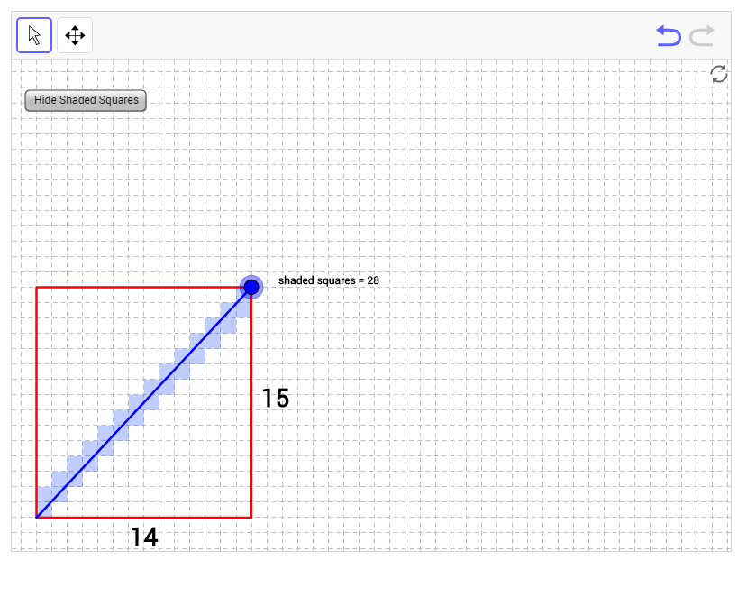

Problem by David Cox
The diagonal of the 3 x 5 rectangle below passes through the interiors of 7 of the 15 squares that comprise it. In general, consider an N x M rectangle. Through how many of the NM squares that comprise the N x M rectangle does the diagonal pass?

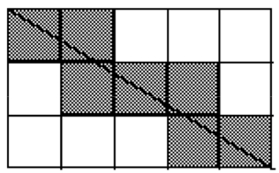

Problem by Alan Schoenfeld
Draw a 9 by 3 rectangle on a square grid. Draw one diagonal. How many squares does the diagonal pass through? Draw some non-similar rectangles with one diagonal. How many squares does the diagonal pass through? Develop a rule to determine the number of squares a diagonal passes through for any rectangle of any size.

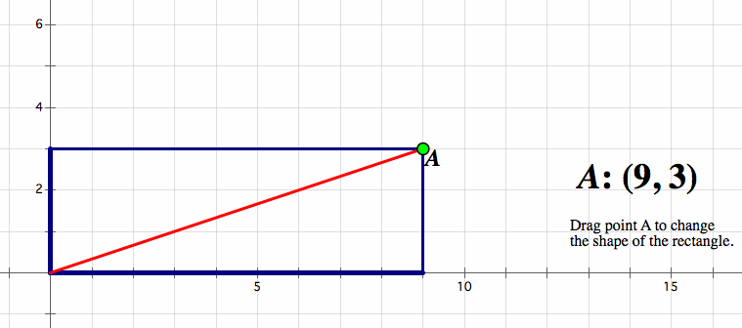

Problem by Kate Nowak

