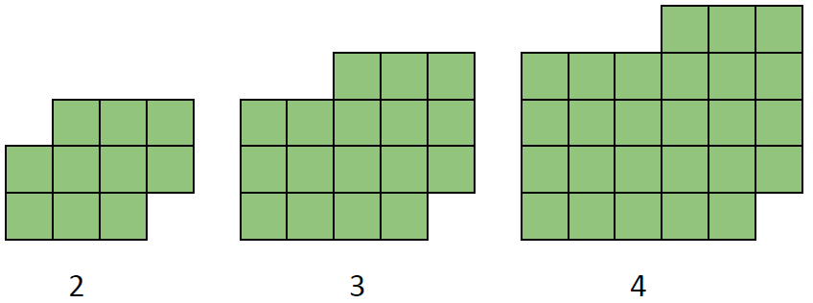

What do you notice?

Pose some questions.

Note: This visual growth sequence is inspired by visualpatterns.org, curated by Fawn Nguyen, a middle school math teacher in California.

