Election Math
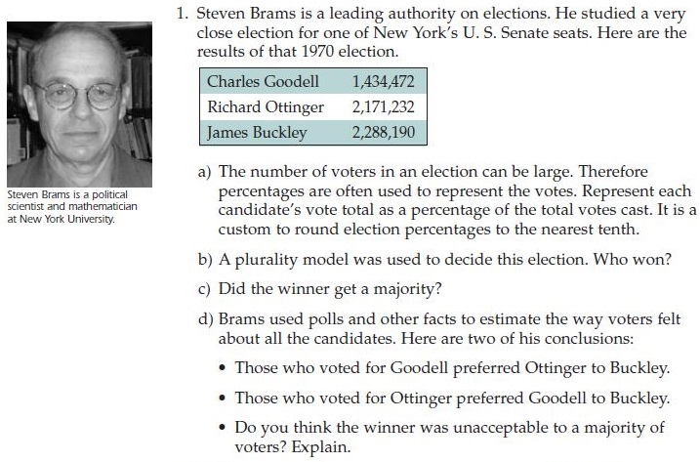
The electoral math used in the United States election process counts votes using a system known as plurality voting. In this system, also known as "first-past-the-post," the candidate with the most votes is declared the winner. Now in an election where there are just two candidates, that system works just fine. It's when there are three or more candidates that problems can arise. Plurality voting can result in the election of a candidate whom almost two- thirds of voters detest.
For instance, in 1998, in a three-party race, plurality voting resulted in the election of former wrestler Jesse Ventura as Governor of Minnesota, despite the fact that only 37% of the electors voted for him. The almost two-thirds of electors who voted Democrat or Republican had to come to terms with a governor that none of them wanted -- or expected. Judging by the comments immediately after the election, the majority of Democrat and Republican voters were strongly opposed to Reform Party candidate Ventura moving into the Governor's mansion. In which case, he won not because the majority of voters chose him, but because plurality voting effectively thwarted the will of the people. Had the voters been able to vote in such a way that, if their preferred candidate were not going to win, their preference between the remaining two could be counted, the outcome could have been quite different.

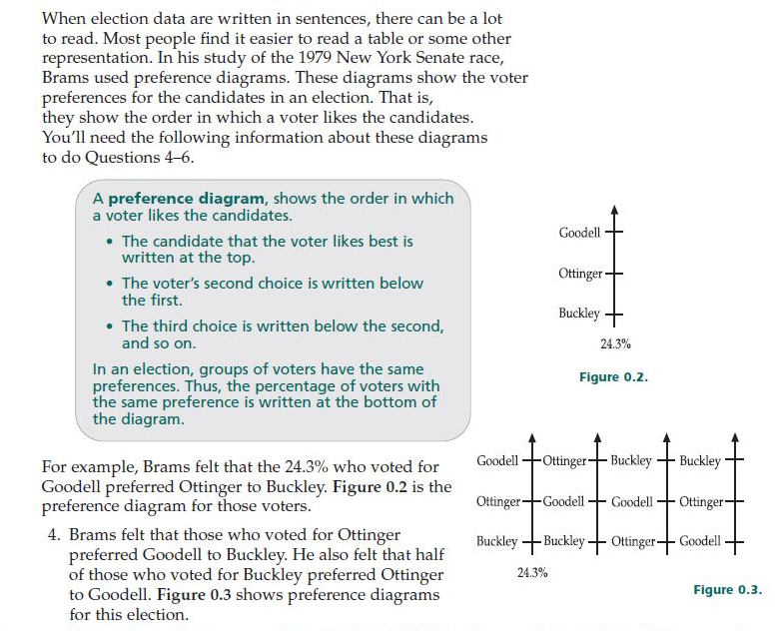
- Finish the preference diagrams by writing the other three percentages.
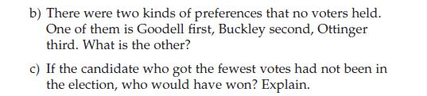
- What implications do you see for our math group name voting?

Note: These textbook excerpts are from Mathematics: Modeling Our World, Ch. 0 Pick a Winner: Decision Making in a Democracy (COMAP). The prose is from The Perplexing Mathematics of Presidential Elections, by Keith Devlin (https://www.maa.org/external_archive/devlin/devlin_11_00.html).

