The Slip Slide Method of Factoring
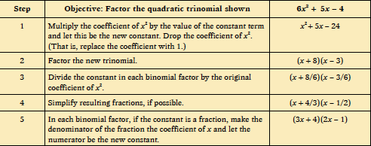

Why does this work? Will this always work?

