*Which of these puzzles and problems do you think could work (with modification possibly) in an adult education math class?* -Eric
Materials: 144 tiles (36 per table), grid paper
Warm-up:
- How many different rectangles can you make with 36 tiles? Each rectangle should be filled in completely and use all 36 tiles. Keep track of the side lengths of your rectangles.
- What do you notice? Notes to yourself, then talk with a partner, then with the group.
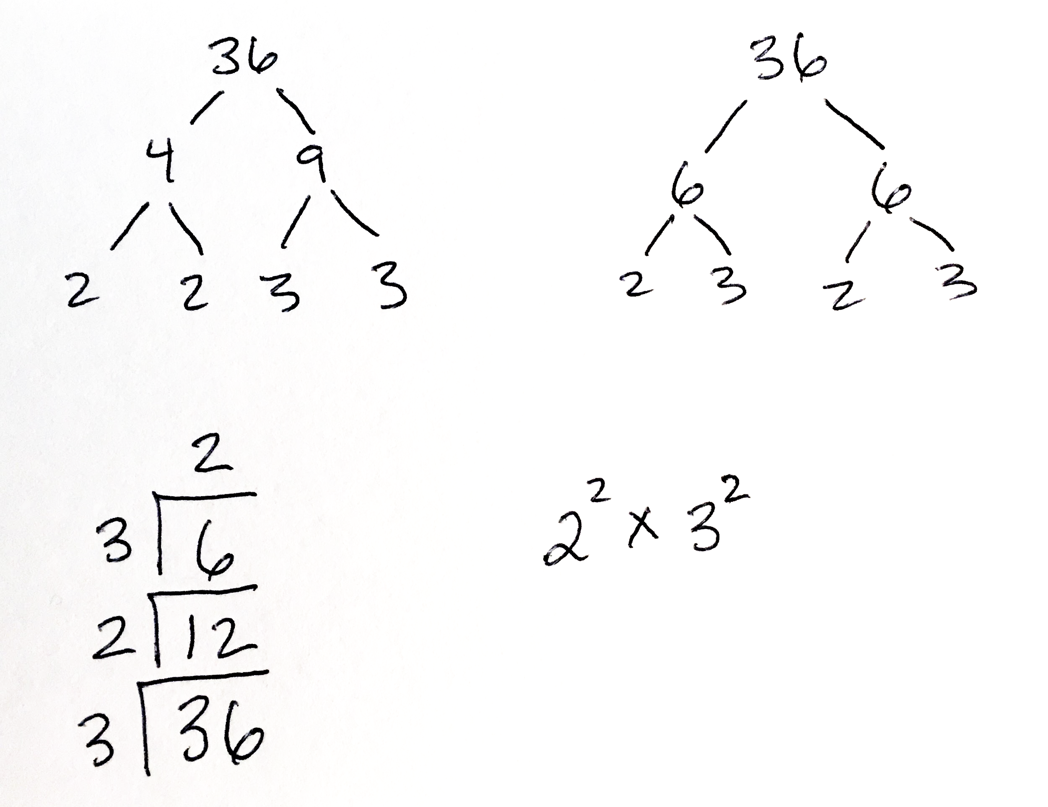
- Do you see ways of determining the lowest common multiple (LCM) and the greatest common divisor (GCD) from any of these representations?
Create area model puzzles:
- Using the area model, multiply a pair of two digit whole numbers, e.g., 24 x 13:
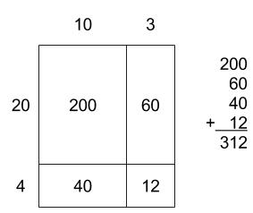
- Keep this next part secret. Pick a pair of two digit whole numbers and create an area model for multiplying them. Label the four partial products but not the sides.
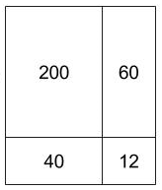
- Exchange your creation with a classmate and see if you can figure out the two-digit numbers you multiplied to get those partial products.
- What strategies did you use to figure out the two-digit numbers that were multiplied to get those partial products? What questions occur to after playing this game?
- Would you recommend using this activity in one of our math classes? If so, how?
Counting Factors
- Consider the operation of counting the factors of a whole number (including 1 and the number itself). You might think of this as a function that counts factors. For example, the number 6 has the factors 1, 2, 3, and 6. If 6 is the input, 4 is the output. The function d of 6 might be written as d(6) = 4.
  - What questions could we ask about this function?
  - If the input to d is 5, what is the output? What if the input is 12?
  - What is d(24)? d(8)?
  - Classify all numbers n so that d(n) = 3. Classify all numbers n so that d(n) = 2.
  - Complete the prime factorization of at least 4 integers. Add the exponents of the prime factors to the table below. (Add more columns if necessary.) What do you notice?
integer | prime factorization | exponent of 1st prime factor | exponent of 2nd prime factor (if there is one) | exponent of 3rd prime factor (if there is one) | number of factors
36 | 2²3² | 2 | 2 |  | 9

  - Find some numbers that d takes to 6.
  - What is the smallest positive integer that has 10 factors?
  - What is the smallest positive integer that has 9 factors?
  - What can you say about a number m if d(m) = 12?
  - Find two numbers n and m so that d(nm) = d(n)d(m). Find 2 more. Compare with what other people have found.
  - What would the graph of d look like?
  - What other questions or activities related to this problem would you use, if any, in one of our math classes?
Graphing GCD Relationships
- Look at the greatest common denominators of 3 and another number.
  - Complete the table below for the relationship f(x) = GCD(3,x).
x | 1 | 2 | 3 | 4 | 5 | 6
f(x)

  - Graph the relationship f(x) = GCD(3,x), where x is a positive integer.
  - Is f a function? Why or why not?
  - Make at least three observations about the graph of f.
- Look at the greatest common denominators of 12 and another number.
  - Graph the relationship f(x) = GCD(12,x), where x is a positive integer.
  - How are the graphs of f and g alike? How are they different?
  - What can you say about the values of g?
  - Use the graph of g to predict the value of g(40). Explain your answer.

- The graph below represents the function m(x) = GCD(k,x) for some constant k < 10. Determine this value of k.
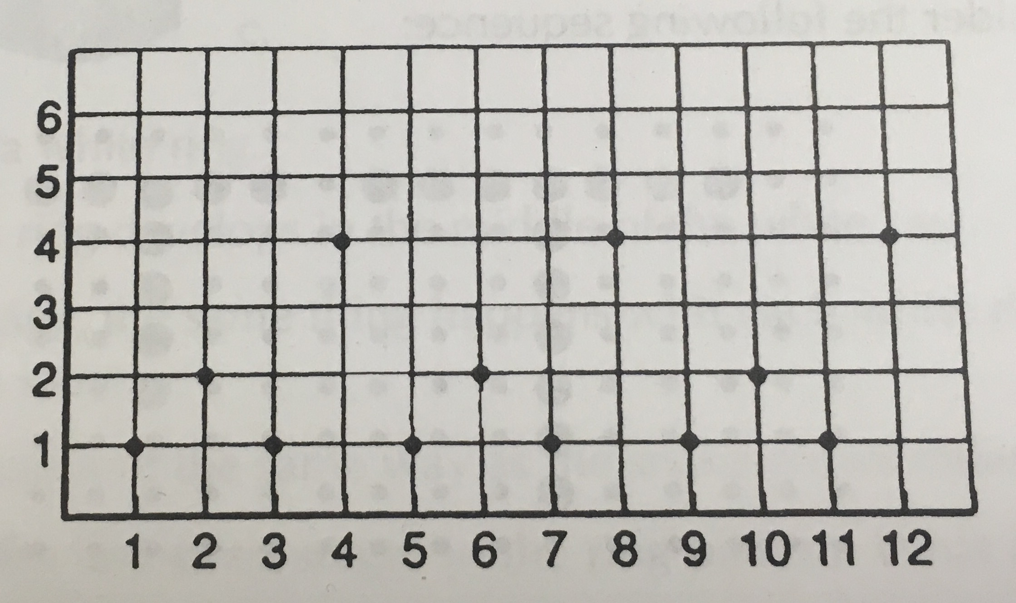
- What other questions or activities related to this problem would you use, if any, in one of our math classes?
Extras
- Denote by LCM the least common multiple and by GCF the greatest common factor.
  - Suppose LCM(A, B) = 252 and GCF(A, B) = 14. Find all possible values for A and B.
  - Suppose LCM(A, B) = 30; LCM(B, C) = 42; and LCM(A, C) = 70. Find all possible values for A, B, and C.

If you have ideas for teaching any of this content in high school equivalency math classes, please email the CAMI list or contact me on Twitter (@eappleton).
Thanks,
Eric

This problem is based on Something Nu from Fostering Algebraic Thinking, by Mark Driscoll.
Also from Driscoll, above.
Thank you to Benjamin Dickman (@benjamindickman) for this activity.
Sometimes known as the divisor function.

