Dana’s Rectangle
Using a sheet of grid paper, Dana marked a rectangle and drew a picture inside the rectangle (in the example below it is dark gray).
Then she surrounded the rectangle by a one-square-wide border consisting of grid squares (in the example below it is light gray).
It turned out that the area of the border is exactly the same as the area of the inside rectangle. What size is the rectangle? List all possible sizes and prove that other sizes won’t work. By the way, the example below doesn’t work.

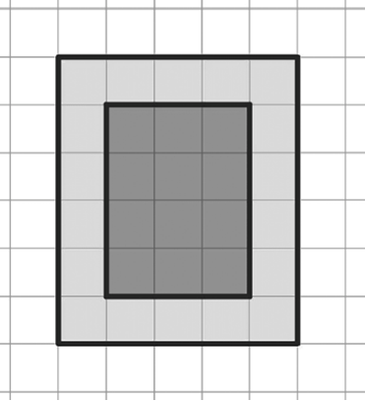

Wait, is Dana’s rectangle even possible?

